PROJECT REPORT TEMPLATE

# THE TABLEAU HR SCORECARD: MEASURING FOR SUCCESS IN TALENT MANAGEMENT

# 1. INTRODUCTION

# 1.1 overview

## Provide an overview of the project, explaining the significance of talent management in organizational success. Highlight the importance of having a well-defined measurement system to evaluate talent management efforts.

# 1.2 purpose

## The primary purpose of this project is to develop and implement a sophisticated measurement tool, leveraging Tableau's capabilities, to effectively evaluate and measure various aspects of talent management within the organization. This includes talent acquisition, development, engagement, and retention. By using the Tableau HR Scorecard, the organization aims to obtain comprehensive and real-time insights, enabling data-driven decision-making for continuous improvement in talent management strategies.

2. PROBLEM DEFINITION & DESIGN THINKING

2.1 Empathy map

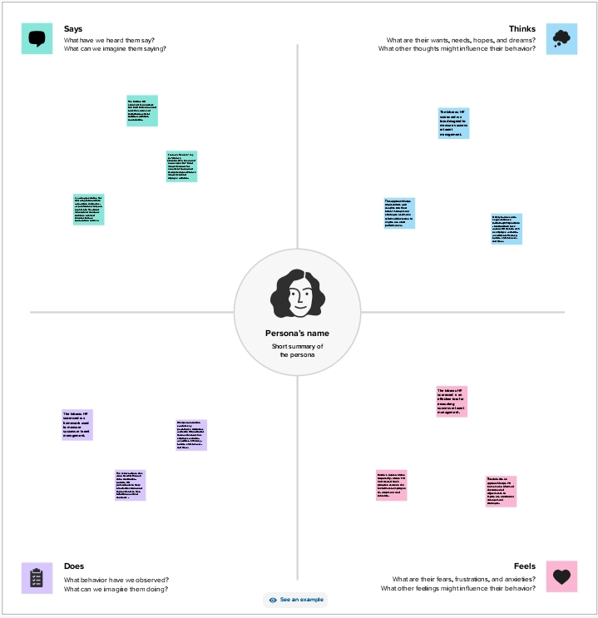

2.2 Ideation & brainstorming map

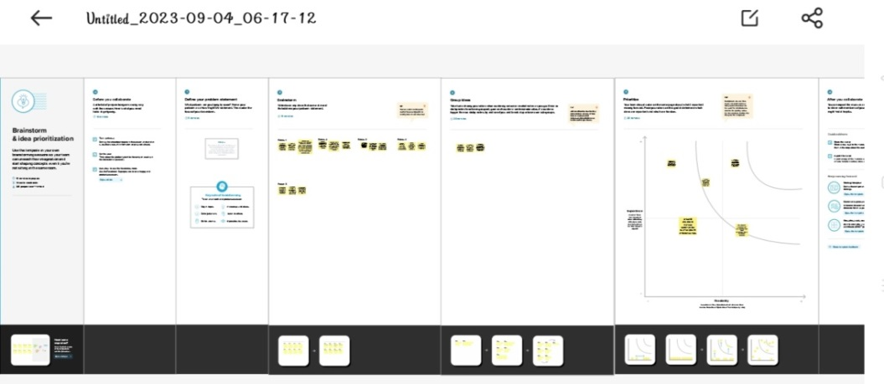

**3. RESULT**

DASHBOARD 1

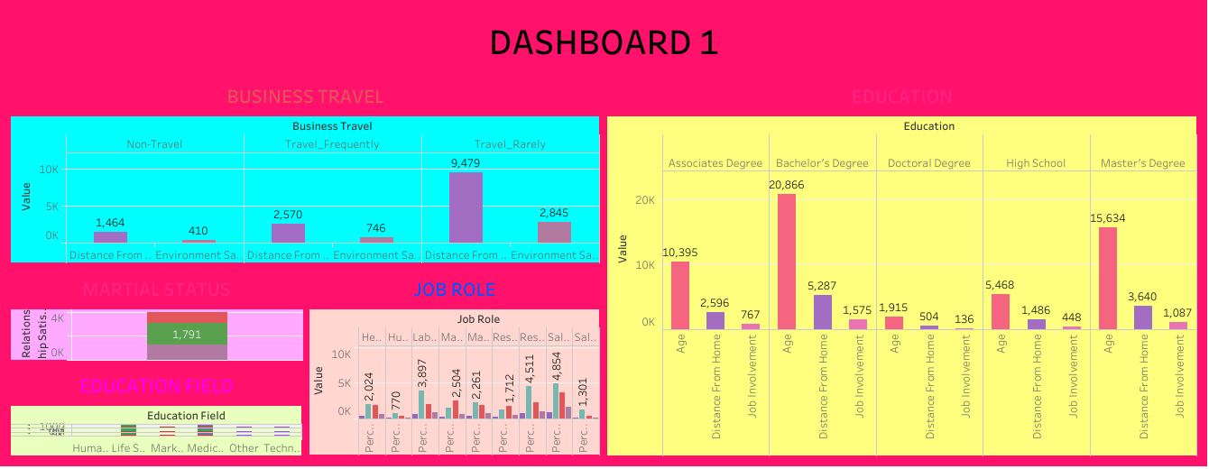

DASHBOARD 2 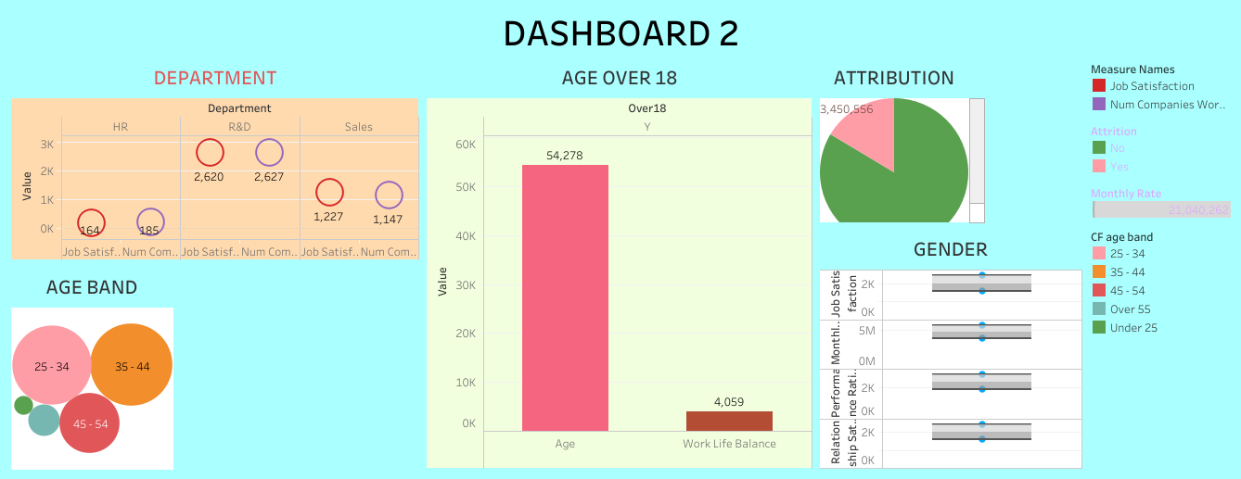

STORY

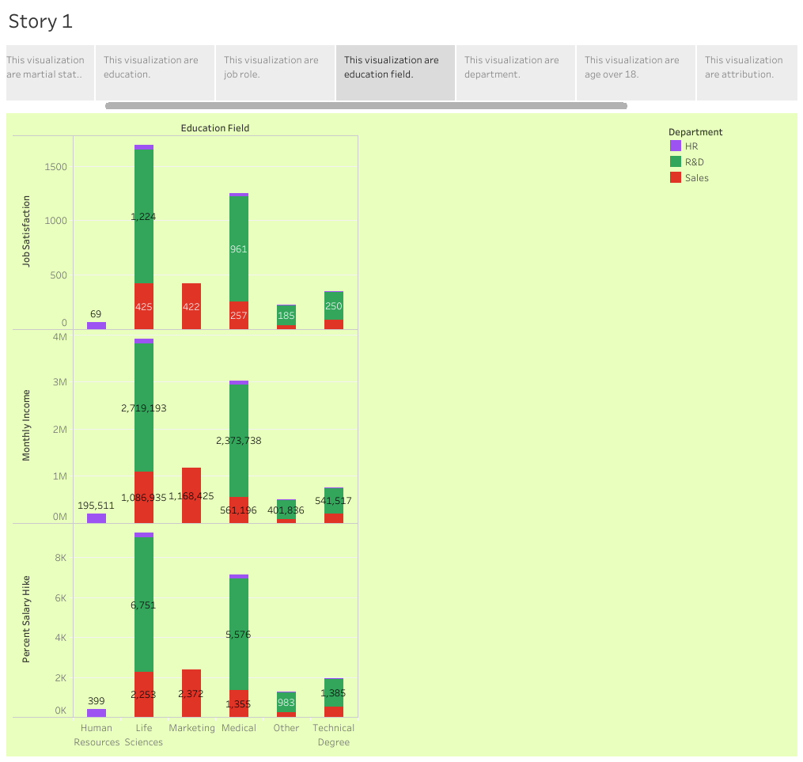

4. ADVANTAGES & DISADVANTAGES

## ADVANTAGES

• High performance : users rate tableaus overall performance as strong and secure.

• Extensive customer resources.

• Excellent mobile support .

• Easy to upgrade.

• Low cost.

• Quality customer service.

DISADVANTAGES :

* If can be an overwhelming framework .
* It cannot be copied precisely from examples.
* It requires strong leadership support to be successful.
* It can be difficult to keep everyone on the same page.
* It may appear too rigid for the way you manage .

## 5.APPLICATIONS

## * Analyze recruitment effectiveness by tracking the time-to-hire, cost per hire, and source of hires.

## * Visualize candidate demographics, skills, and qualifications for better recruitment strategies.

## * Monitor training program effectiveness by visualizing employee skill development and training completion rates.

## * Track employee progress in development programs and identify areas for further training.

## 6.CONCLUSION

## The HR Scorecard powered by Tableau has provided rich, actionable insights into our talent management strategies. It has empowered decision-makers with a clear view of key performance indicators and trends, facilitating informed, data-driven decision-making.

# 7.FUTURE SCOPE

## Include metrics related to employee wellness and mental health within the HR scorecard, enabling organizations to monitor and support employee well-being for improved productivity and job satisfaction.

## 8. APPENDIX

A SOURCE CODE

## 1.DATA LINK

## <https://drive.google.com/file/d/1TQLqjUgSthNTeM2_XRCqAwbrGChk-M5I/view?usp=sharing>

2. DASHBOARD LINK

DASHBOARD 1

<https://public.tableau.com/views/HRSCORECARD_16965778991970/Dashboard2?:language=en-US&:display_count=n&:origin=viz_share_link>

DASHBOARD 2

<https://public.tableau.com/views/HRSCORECARD2/Dashboard3?:language=en-US&:display_count=n&:origin=viz_share_link>

## 3 . STORY LINK

<https://public.tableau.com/views/HRSCORECARDSTORY_16965780269710/Story1?:language=en-US&:display_count=n&:origin=viz_share_link>